**D210 Performance Assessment**

**DATA DASHBOARD AND STORYTELLING**

Fahim A. Akbar Student ID 001434895 Masters Data Analytics (January 1, 2021) Program Mentor: Lea Yoakem (877) 435-7948x6422 [fakbar3@wgu.edu](mailto:fakbar3@wgu.edu)

**Part 1: Interactive Data Dashboard**

Link to the dashboard: [D210 Dashboard - Diabetic Patient Demographics by Fahim Akbar](https://public.tableau.com/app/profile/fahim.akbar2939/viz/D210Dashboard-DiabeticPatientDemographicsbyFahimAkbar/Dashboard1?publish=yes)

**1. Datasets**

The data sets that serve as the data source for my dashboard are “1medical_clean” and “1diabetic_dataset.” **DataSet 1** is represented by the medical_clean data set and **DataSet 2** is represented by the diabetic dataset.

Source for “1medical_clean” <https://tasks.wgu.edu/student/001434895/course/23540008/task/2804/overview>

Source for “1diabetic_dataset”

<https://www.kaggle.com/code/chongchong33/predicting-hospital-readmission-of-diabetics/notebook>

**2. Installation**

Installation is not required. The dashboard is publicly available in the link provided below

[D210 Dashboard - Diabetic Patient Demographics by Fahim Akbar](https://public.tableau.com/app/profile/fahim.akbar2939/viz/D210Dashboard-DiabeticPatientDemographicsbyFahimAkbar/Dashboard1?publish=yes)

**3. Interactive controls**

All filters and keys are located on the right-hand side of the dashboard.

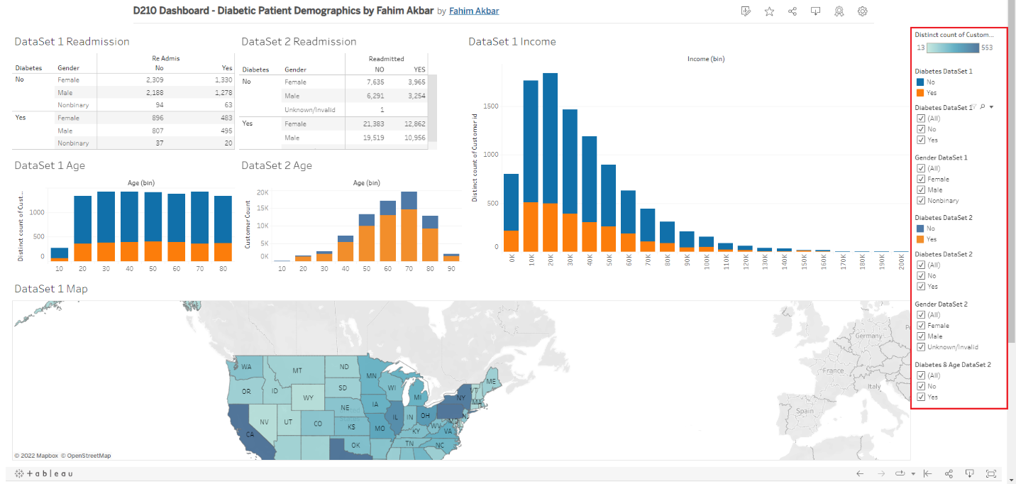

For the visualizations, colors from the Tableau color blind palette were used. By default all categories in the filters are selected. To deselect whichever category you would like to filter out, click on the respective box and make sure the checkmark is no longer present.

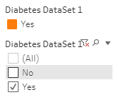

**Readmission and Diabetes**

You can filter the Readmissions tables by diabetes and gender.

1. For DataSet 1, use the “Diabetes DataSet 1” filter to filter patients by if they have (Yes) or do not have (No) diabetes.
2. To filter the DataSet 1 table by Gender, select or deselect the boxes in Gender DataSet 1. 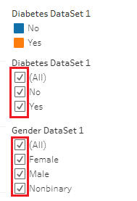
3. For DataSet 2, use the “Diabetes DataSet 2” filter to filter patients by if they have (Yes) or do not have (No) diabetes.
4. To filter the DataSet 2 table by Gender, select or deselect the boxes in Gender DataSet 2. 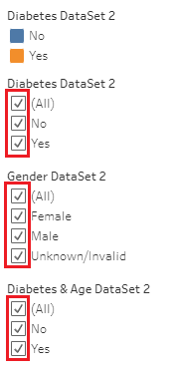

**Age and Diabetes**

The Age charts can be filtered and include and exclude patients with or without diabetes.

1. For DataSet 1, use the Diabetes DataSet 1 filter and select “Yes” to filter for patients with Diabetes; deselect “No” to filter out patients that do not have diabetes.



1. For DataSet 2, use the Diabetes & Age DataSet 2 filter. Select “Yes” to filter for patients with Diabetes; deselect “No” to filter out patients that do not have diabetes. 

**Additional controls**

The Diabetes DataSet 1 filter can also be used to filter the DatSet 1 Income and DataSet 1 Map visualizations.

